**Enterprise Resource Planning**

**Training User Manual**

**VERSION 12.0.0**

**Serial History & Reports**

# [Serial](http://192.168.1.17:8090/zab/login?screen=opdoheader&option=Invoice+Entry&menuname=op) History

|  |  |
| --- | --- |
| **Step 1** | Open System **>** [Searching Option](javascript:run1()&menuname=search) >[Serial History](http://192.168.1.17:8080/zab/login?screen=advancesrc&option=Serial+History&menuname=search) |
| **Step 2** | Select serial Number of the product. |
| **Step 3** | Click **Show** |
| **Result** | The detail of the product is showing for the specified serial number. |

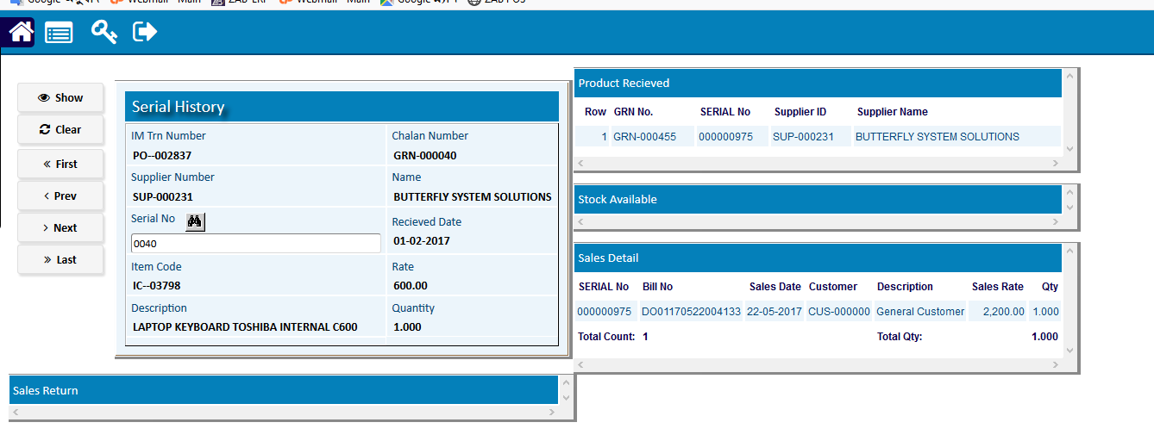

# Reports

## Printing report to preview data

|  |  |  |  |
| --- | --- | --- | --- |
| **Step 1** |  |  | Open System **>** Sales & Invoice **>** Reports |
| **Step 2** |  |  | Select a report option. |
| **Step 3** |  |  | Select the start date, end date & other fields to specify data previewing in the report. |
| **Step 4** |  |  | Click **“View Report”** to preview in print format. |
| **Result** |  |  | The report is previewed in print format. |

